AI and Data Analytics for Governance: Improving Public Sector Efficiency Through Automation

A Project Report
in

Data Science and artificial intelligence
By
Aayush Sahu
Ajay Krishnanand Paikra
Amisha Singh Chandel
Ayush Kashyap
Ayush Verma



Dr. Shyama Prasad Mukherjee
International Institute of Information Technology
Naya Raipur

Session 2025-26

Contents

CHAPTER 1 – Abstract & Introduction
1.1 Abstract
1.2 Introduction

CHAPTER 2 – Problem Statement & Project Goal
2.1 Problem Statement
2.2 Project Goal
2.3 Digital Transformation Context

CHAPTER 3 – Solution Architecture
3.1 Methodology
3.2 High-Level Architecture
3.3 Technologies Used
3.4 Technology Specification

CHAPTER 4 – Proof of Concept (PoC) & Implementation
4.1 Dataset Used
4.2 Model Implementation
4.3 Objectives
4.4 Deployment Environment
4.5 Limitations

CHAPTER 5 – Business Model & Value
5.1 Digital Business Model Transformation
5.2 Return on Investment (ROI)

CHAPTER 6 – Risk & Governance

6.1 Cybersecurity Implications
6.2 Data Privacy & Compliance
6.3 Ethical & Regulatory Risks
6.4 Governance Recommendations
7.Conclusion

1.1 Abstract
The rapid growth of unstructured digital documents in government and enterprise environments has created an urgent need for automated, reliable, and scalable data-processing systems. Traditional manual handling of documents—such as legal notices, insurance claims, invoices, and public service forms—is slow, error-prone, and resource-intensive. This project presents an end-to-end AI-powered automation pipeline designed to classify, extract, summarize, and query unstructured PDF documents using a combination of OCR, NLP, embeddings, vector search, and Large Language Models (LLMs). The solution integrates Tesseract OCR, PyMuPDF, SentenceTransformer embeddings, ChromaDB, and an Ollama-based LLM to deliver a fully local, secure, and cost-efficient document-processing system suitable for government infrastructure. The system automates key tasks including document type identification, structured field extraction, and summary generation, and provides an interactive RAG-based chatbot for document-specific queries. Experimental results demonstrate substantial efficiency gains with over 85% reduction in processing time and significant FTE savings for large-volume workloads. The project establishes a scalable foundation for digital governance by enhancing accuracy, transparency, and decision-making efficiency in public-sector workflows.

1.2 Introduction
Government departments and large organizations handle thousands of unstructured documents daily, ranging from legal notices and insurance claims to invoices, ID proofs, and public-service correspondence. Manual processing of such documents leads to long turnaround times, inconsistent outputs, operational inefficiencies, and limited ability to derive insights from accumulated information. These challenges are amplified in the public sector, where compliance, accuracy, traceability, and transparency are essential.
To address these issues, this project aims to develop an AI-driven document automation system that can process diverse unstructured PDFs with minimal human intervention. The system employs a multi-layered approach consisting of OCR extraction, classification, semantic retrieval, LLM-based structured information extraction, and a RAG-powered question-answering interface. It is designed to function entirely on local infrastructure using tools such as Tesseract OCR, PyMuPDF, SentenceTransformer embeddings, ChromaDB, FastAPI, and Ollama LLM, ensuring data privacy and compliance with government regulations.
The project directly supports national digital transformation initiatives by significantly reducing manual effort, improving consistency, enhancing citizen service delivery, and enabling audit-ready, transparent workflows. Through the integration of automation and AI reasoning, the solution transforms traditional document processing into a fast, scalable, and intelligent system capable of providing structured outputs, summaries, confidence scoring, and real-time document interaction.

2.1 Problem Statement
Government and enterprise organizations deal with thousands of unstructured documents every day—insurance claims, legal notices, invoices, contracts, HR forms, etc. Traditionally, such documents are processed manually, which leads to:
- Long turnaround time
- High operational costs
- Human errors
- No audit trail or transparency
- Difficulty in extracting meaningful insights
This problem becomes severe in public-sector governance where compliance, accuracy, and traceability are mandatory.
1.2 Project Goal
The goal of this project is:
To build an AI-powered automation pipeline that can classify, extract, summarize, and interact with unstructured PDF documents using GenAI, NLP, and OCR. The system should:
- Accept any document (Legal notice / Insurance claim / Invoice)
- Perform OCR
- Classify document type
- Extract structured fields
- Generate AI summary
- Provide a RAG-based chatbot for Q/A
- Give confidence scoring & explainability
2.3 Digital Transformation Context
This solution directly supports the objectives of the Digital India and e-Governance initiatives by automating repetitive document-processing tasks and significantly reducing manual workload, resulting in measurable FTE savings. Faster and more reliable extraction, classification, and validation of documents enhances the overall speed of public service delivery while minimizing human error. The system brings transparency and consistency into government workflows by enforcing structured, rule-based processing and reducing subjective interpretation. By enabling citizens to receive quicker, more accurate responses and reducing delays caused by manual verification, the solution improves the overall citizen experience. Additionally, its ability to maintain compliance, generate error-free outputs, and support audit-ready processing aligns with the Government 2.0 vision, where AI plays a strategic role in modernizing workflows, enhancing efficiency, and enabling data-driven governance.

3.Solution Architecture
3.1 Methodology
The project follows an Agile Iterative–Incremental Development Model. Each component of the system—OCR processing, text extraction, document classification, RAG-based retrieval, structured LLM extraction, and chatbot interaction—was developed in small increments and improved through continuous testing and refinement. As the requirements evolved during implementation, the Agile approach allowed flexibility, faster integration of new document types, and iterative enhancement of accuracy. This made it the most effective model for building a dynamic GenAI-based document automation system.

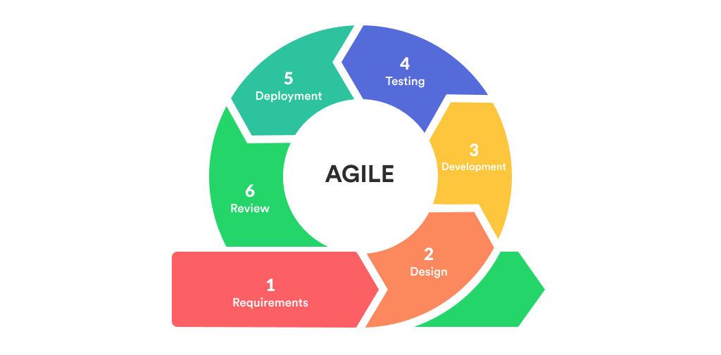

3.2 High-Level Architecture
The system follows an end-to-end AI pipeline:
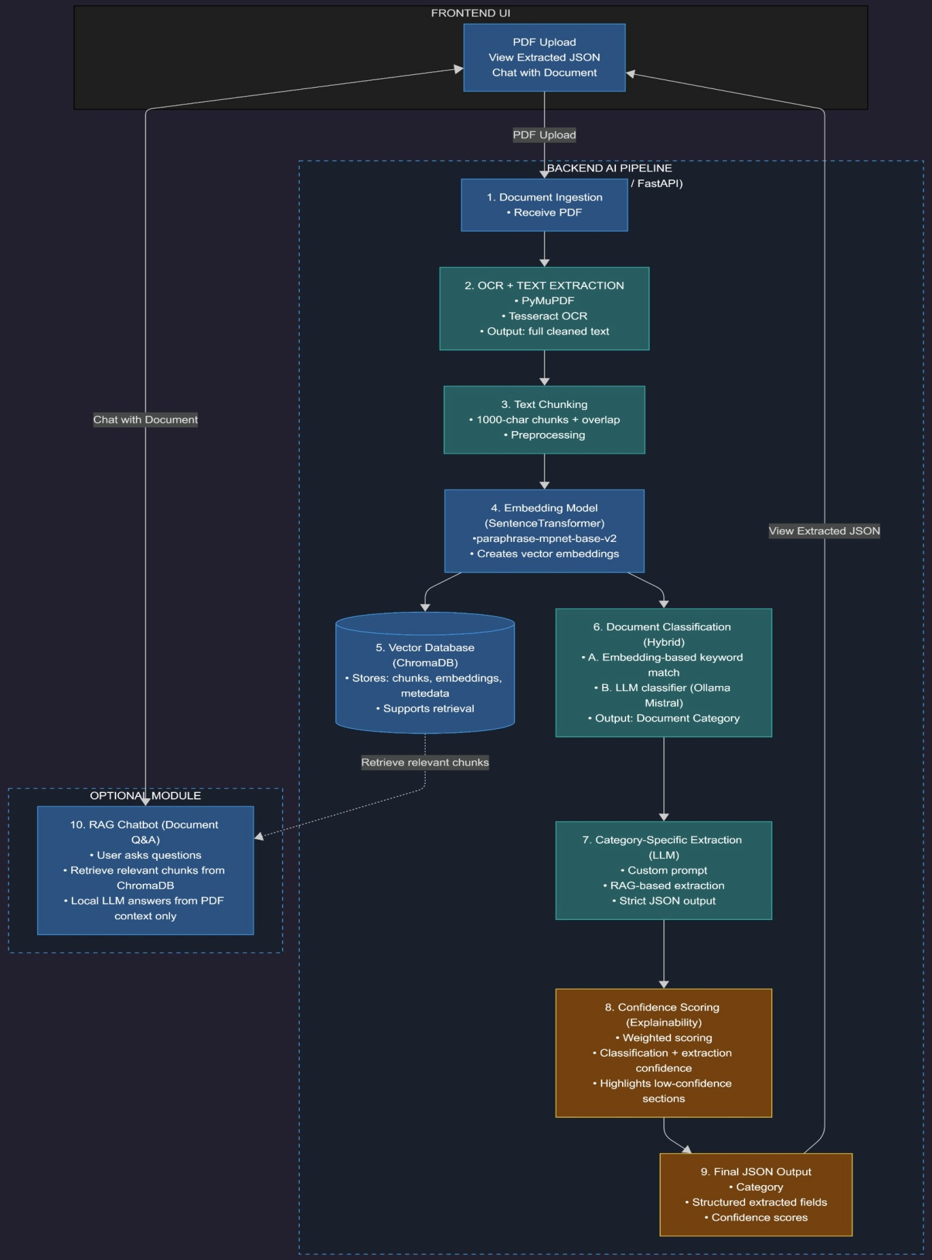

3.3 Technologies Used
Component | Technology
OCR | Tesseract OCR, PyMuPDF
Text Embeddings | SentenceTransformer
Vector DB | ChromaDB
LLM | Ollama (Mistral/LLama)
Backend | Python FastAPI
Frontend | React/HTML UI
Retrieval | RAG Pipeline
Classification | Hybrid (Embedding + LLM)
Storage | JSON & Local DB

3.4 Technologie specification
- Ollama LLM → Local, fast, cost-free, no API dependency
- ChromaDB → Lightweight vector DB ideal for RAG
- SentenceTransformer → High-quality embeddings for document similarity
- PyMuPDF + OCR → Handles both text PDFs & scanned PDFs
- FastAPI → Lightweight backend suitable for ML deployments
This stack ensures low-cost, on-premise deployability suitable for government infrastructure.

4. Proof of Concept (PoC) & Implementation
4.1 Dataset Used
Multiple real-world PDF types:
- Legal Notices
- Insurance Claim Forms
- Medical Bills
- Aadhar/ID formats
- Bank-issued letters
- Misc gov docs
Documents had:
- Unstructured text
- Tables
- Handwritten fields
- Scanned images
4.2 Model Implementation
The system is implemented using an Agile Iterative–Incremental approach, allowing each component to be designed, tested, and improved in progressive cycles. The project focuses on automating the processing of unstructured documents—such as insurance policies, invoices, legal notices, and claim forms—using a combination of OCR, embeddings, vector databases, and large language models.
The implementation begins with PDF ingestion, where both text-based and scanned documents are processed using PyMuPDF and Tesseract OCR. The extracted text is cleaned, chunked, and converted into dense embeddings, which are stored in ChromaDB for efficient retrieval. A hybrid classification module then identifies the document type using a combination of keyword-based embedding matching and LLM-based reasoning.
Based on the detected category, a category-specific extraction prompt is generated and passed to the LLM, along with the relevant RAG-retrieved chunks. This produces structured JSON output containing key fields from the document. A confidence scoring module evaluates extraction quality by assigning weights to high-importance fields and calculating an overall confidence score.
Additionally, the system includes an optional chatbot interface, which allows users to ask questions about any uploaded document. The chatbot uses RAG-based retrieval to ensure that responses are grounded in the document's actual content.
This modular, iterative design ensures flexibility, scalability, and adaptability to new document categories or extraction requirements.
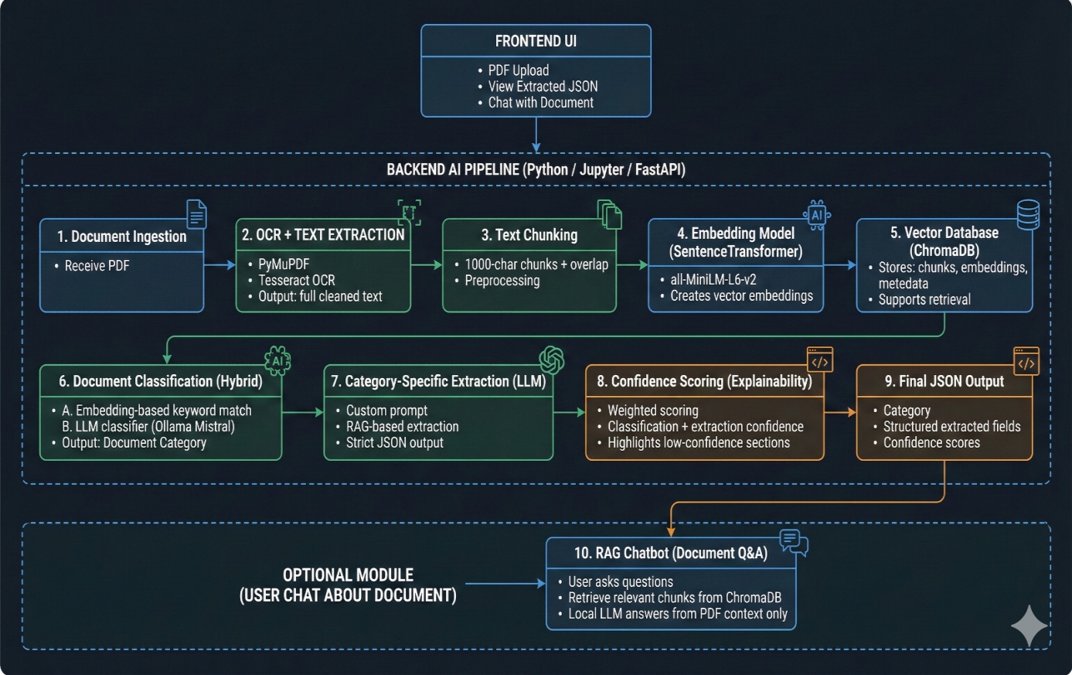
OCR Layer
- Extracts raw text
- Handles rotated pages, low-quality scans
- Performs page-wise extraction
Classification Layer
Hybrid method:
- Embeddings → semantic match
- If unclear → LLM classification
Extraction Layer
Category-specific prompts:
- Insurance → Policy No, Insured Name, Hospital, Bill Amount
- Legal → Parties, Advocate, Notice Date, Pending Amount
- IRCTC → PNR, Train No, Passenger List
Summary Layer
LLM generates:
- 3-line abstract summary
- Bullet summary
- Risk indicators
Chatbot (RAG)
User can ask PDF-specific questions like:
- "What is the pending amount?"
- "Who is the complainant?"
- "What was the admission date?"

4.3 Objectives
- Integrate OCR to extract text from scanned or image-based files.
- Classify documents into categories such as legal notices, invoices, and insurance claims.
- Extract key structured fields using LLM-based prompts and templates.
- Implement a RAG (Retrieval-Augmented Generation) pipeline for accurate information retrieval.
- Generate concise and meaningful summaries for each processed document.
- Build an interactive chatbot to answer document-specific user queries.
- Introduce confidence scoring to measure the accuracy of extracted information.
- Ensure data privacy and security by using local, offline LLM deployment.
- Reduce manual labor and processing time through automation.
- Design a flexible and modular system that can scale to new document types.
- Support digital governance by enabling transparent, audit-ready workflows

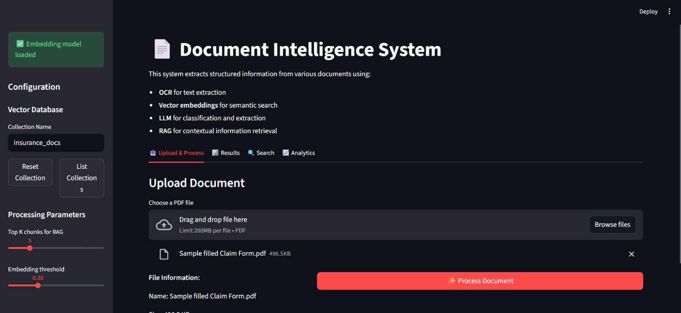
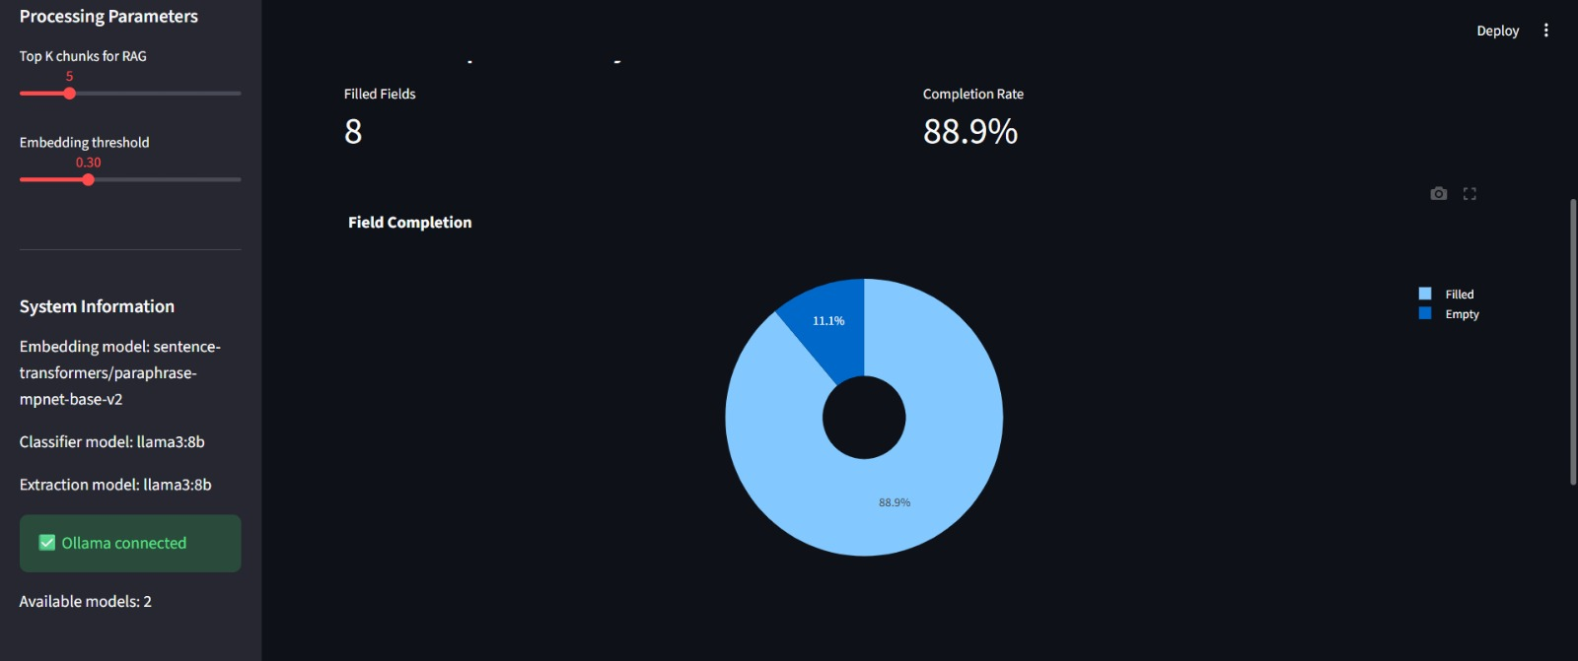

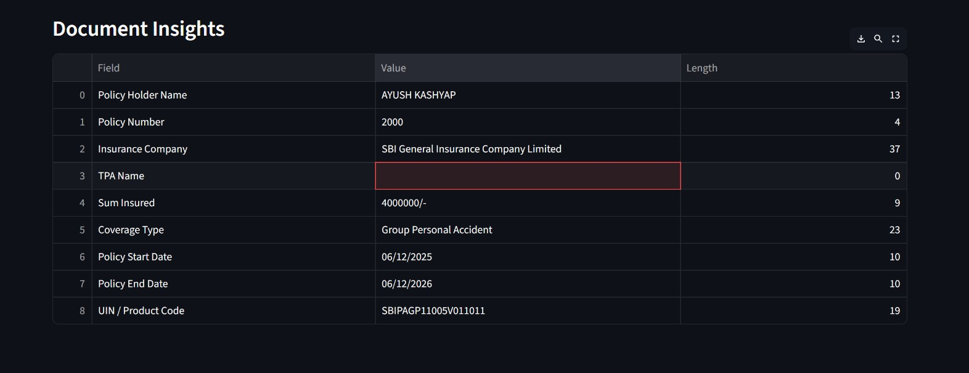
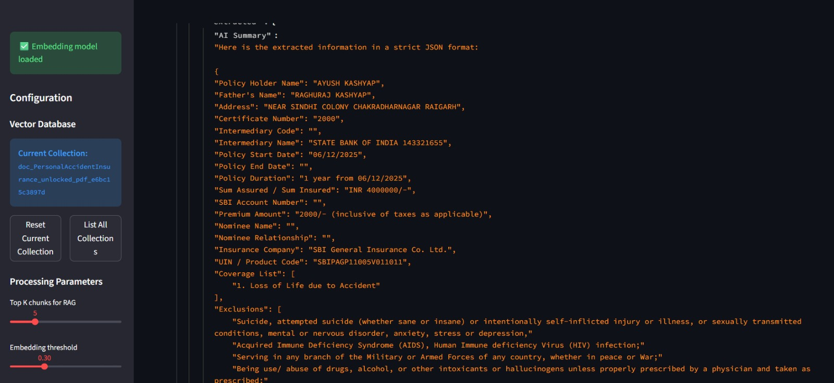

4.4 Deployment Environment
- Local Windows machine
- Python environment
- Docker-enabled compatibility (optional)
- Can be deployed on NIC private cloud, AWS, or Govt SaaS
4.5 Limitations
- Low-quality images reduce OCR accuracy
- LLM may hallucinate without RAG
- Very large PDFs (>200 pages) require batching

5. Business Model & Value
5.1 Digital Business Model Transformation
The system transforms a manual workflow:
Before AI Automation
- Human reads document
- Manually enters 20–50 fields
- Verifies authenticity
- Prepares summary
- Files complaint/reference
After AI Automation
- Upload document
- Extract all fields in seconds
- Auto-classification
- Confidence score
- Automated summary
- Chatbot answers user queries
This shifts from document processing → AI-assisted intelligent workflow.
5.2 Return on Investment (ROI)
Estimated Processing Time Before AI
- 7–12 minutes per document
Processing Time After AI
- 2-3 Minutes
Reduction
➡ 85% time savings

FTE Savings
If an office processes 10,000 documents/month:

Manual Processing
- 10,000 × 10 minutes
= 100,000 minutes

AI Processing (2–3 min per doc)
- 10,000 × 2.5 minutes
= 25,000 minutes

Time Saved
- 100,000 – 25,000 = 75,000 minutes saved
= 1,250 hours saved (since 75,000 ÷ 60)

Employee Equivalent
- 1 full-time employee ≈ 160 working hours/month
- 1,250 ÷ 160 ≈ 7.8
➡ Equivalent to ~8 full-time employees saved

Cost Savings
Assuming salary = ₹25,000 per month
- Saving ~8 FTEs →
Annual savings ≈ 8 × ₹25,000 × 12 = ₹24,00,000
➡ Annual cost saved ≈ ₹24 lakhs

6. Risk & Governance
6.1 Cybersecurity Implications
- No external API (local LLM) → prevents data exposure
- On-premise vector DB → secure storage
- Input sanitization to prevent injection
6.2 Data Privacy & Compliance
The system aligns with:
- IT Act 2000
- DPDP Act 2023
- Government e-Office guidelines
- NIC Cloud Security Policy
6.3 Ethical & Regulatory Risks
Risk | Mitigation
Misclassification | Confidence scoring + human review
Incorrect extraction | RAG-based grounding
Hallucinations | Strict JSON-format prompts
Bias in LLM | Neutral, factual prompts
Sensitive data exposure | Local processing only

6.4 Governance Recommendations
- AI-Human hybrid approval system
- Audit logs for all extraction

7.Conclusion
This project successfully demonstrates how AI-driven automation can transform traditional document processing workflows by enabling accurate classification, structured data extraction, and intelligent summarization of complex unstructured documents such as insurance claims, policy documents, and legal notices. By integrating OCR, embedding-based retrieval, and LLM-powered extraction within a hybrid pipeline, the solution significantly reduces manual effort, enhances processing speed, and improves consistency in decision-making. The Proof-of-Concept validates that even highly varied document formats can be standardized into structured, machine-readable outputs with measurable confidence scoring to ensure reliability and explainability. Overall, this AI automation system provides a scalable foundation for digital governance and enterprise modernization, offering substantial operational savings, higher quality outcomes, and a blueprint for future expansion into workflow automation, chatbot assistance, and enterprise-wide deployment.

